Text to SQL

Employee Management Schemas

Employee
Employee (
employee_id INT PRIMARY KEY,
first_name VARCHAR(50),
last_name VARCHAR(50),
email VARCHAR(100) UNIQUE,
phone VARCHAR(15),
hire_date DATE,
employment_status VARCHAR(20),
designation_id INT,
department_id INT,
created_at TIMESTAMP
)

Employee_Personal_Details
Employee_Personal_Details (
employee_id INT PRIMARY KEY,
date_of_birth DATE,
address TEXT,
emergency_contact_name VARCHAR(100),
emergency_contact_phone VARCHAR(15),

Department
Department (
department_id INT PRIMARY KEY,
department_name VARCHAR(100),
department_head INT
)

Designation
Designation (
designation_id INT PRIMARY KEY,
title VARCHAR(100),
level VARCHAR(50)
)

Manager_Hierarchy
Manager_Hierarchy (
employee_id INT,
manager_id INT,
PRIMARY KEY (employee_id, manager_id)
)

Skill
Skill (
skill_id INT PRIMARY KEY,
skill_name VARCHAR(100),
category VARCHAR(50)
)

Employee_Skill
Employee_Skill (
employee_id INT,
skill_id INT,
proficiency_level VARCHAR(20),
experience_years DECIMAL(3,1),
PRIMARY KEY (employee_id, skill_id)
)

Certification
Certification (
certification_id INT PRIMARY KEY,
certification_name VARCHAR(150) NOT NULL,
issuing_organization VARCHAR(150),
certification_level VARCHAR(50),
description TEXT,
validity_years INT,
is_active BOOLEAN DEFAULT TRUE,
created_at TIMESTAMP DEFAULT CURRENT_TIMESTAMP
)

Employee_Certification
Employee_Certification (
employee_id INT,
certification_id INT,
issue_date DATE,
expiry_date DATE,
PRIMARY KEY (employee_id, certification_id)
)
``

Client
Client (
client_id INT PRIMARY KEY,
client_name VARCHAR(150) NOT NULL,
industry VARCHAR(100),
contact_person VARCHAR(100),
contact_email VARCHAR(100),
contact_phone VARCHAR(20),
country VARCHAR(50),
contract_start_date DATE,
contract_end_date DATE,
client_status VARCHAR(30), -- Active, On-Hold, Closed
created_at TIMESTAMP DEFAULT CURRENT_TIMESTAMP
)

Project
Project (
project_id INT PRIMARY KEY,
project_name VARCHAR(150) NOT NULL,
project_code VARCHAR(50) UNIQUE,
client_id INT,
project_manager_id INT,
start_date DATE,
end_date DATE,
estimated_end_date DATE,
project_status VARCHAR(30),
budget DECIMAL(12,2),
billing_type VARCHAR(30),
description TEXT,
created_at TIMESTAMP DEFAULT CURRENT_TIMESTAMP
)

Project_Technology
Project_Technology (
project_id INT,
skill_id INT,
usage_level VARCHAR(30),
version VARCHAR(50),
PRIMARY KEY (project_id, skill_id)
)

Employee_Project
Employee_Project (
employee_id INT,
project_id INT,
role VARCHAR(50),
start_date DATE,
end_date DATE,
PRIMARY KEY (employee_id, project_id)
)

Resource_Allocation
Resource_Allocation (
employee_id INT,
project_id INT,
allocation_percentage INT,
allocation_status VARCHAR(30),
PRIMARY KEY (employee_id, project_id)
)

Employee_Availability
Employee_Availability (
employee_id INT PRIMARY KEY,
availability_status VARCHAR(30),
available_from DATE
)

Attendance
Attendance (
attendance_id INT PRIMARY KEY,
employee_id INT,
attendance_date DATE,
login_time TIME,
logout_time TIME
)

Leave_Type

Leave

Performance_Review

Training

Employee_Training

Asset

Employee_Asset

User_Login

Text-To-SQL

Semantic Layer
A semantic layer is a business-friendly abstraction over raw database tables.
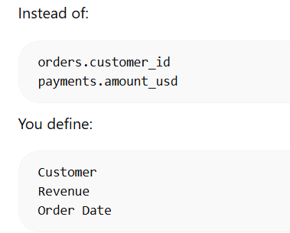

Step 1: Build the Semantic Layer (Offline Step)
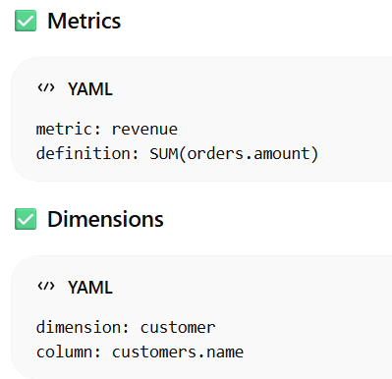
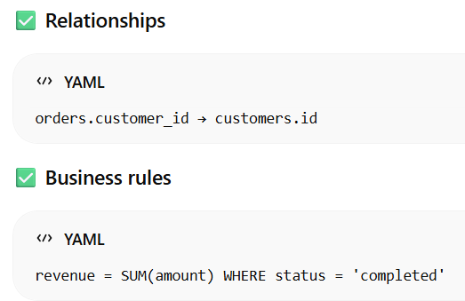

Step 2: User Inputs Natural Language
Example:
“Show top 5 customers by revenue last month”

Example:
“Show top 5 customers by revenue last month”

Step 3: LLM Parses Intent (NOT SQL yet)
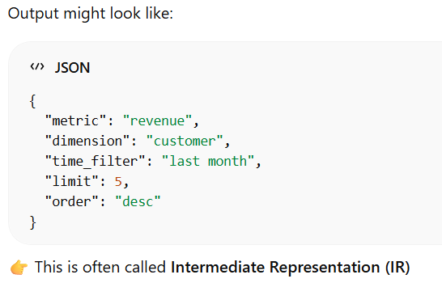

Step 4: Map to Semantic Layer Objects

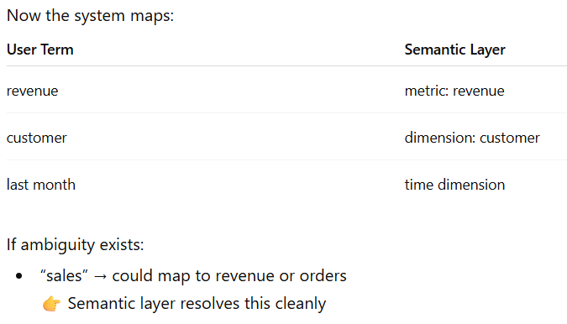

Step 5: Metric Resolution Engine

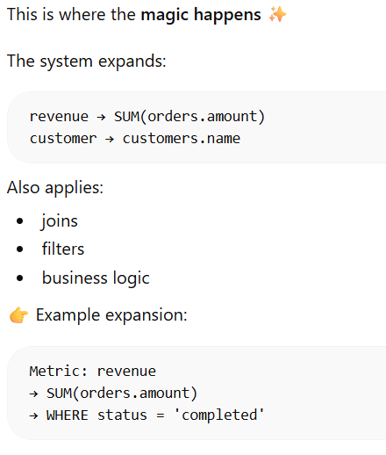

Step 6: Join Path Resolution

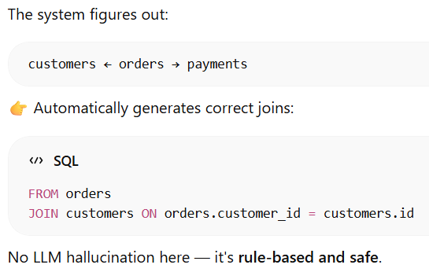

Step 7: SQL Generation (Deterministic)
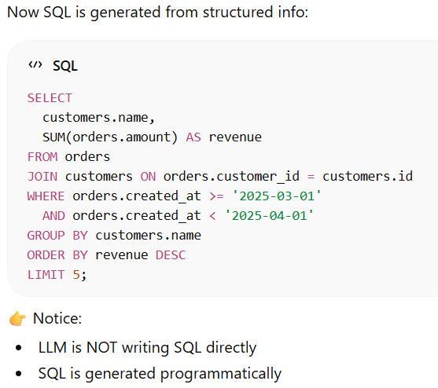

Step 8: Validation Layer

How Query Engine Generate SQL Query

From LLM engine receives something like this

From LLM:
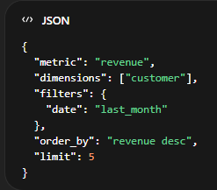
From the semantic layer:
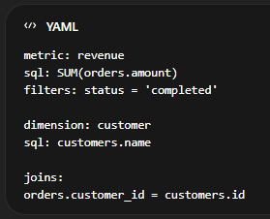

Step 1: Resolve Metrics → SELECT Expressions

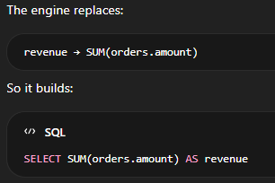

Step 2: Resolve Dimensions → GROUP BY + SELECT

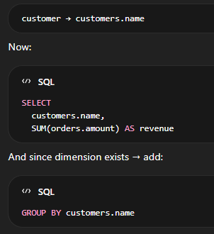

Step 3: Identify Base Table (Anchor Table)

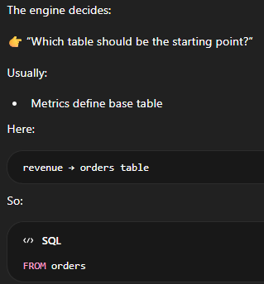

Step 4: Resolve Joins (Join Graph Traversal)

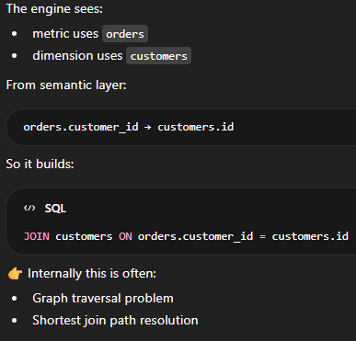

Step 5: Apply Metric-Level Filters

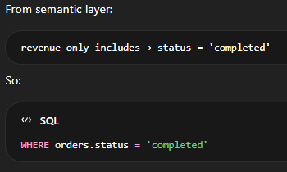

Step 6: Apply User Filters

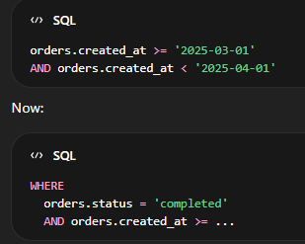

Step 7: Apply ORDER BY

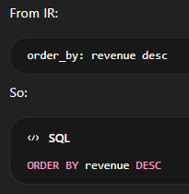

Final SQL Output

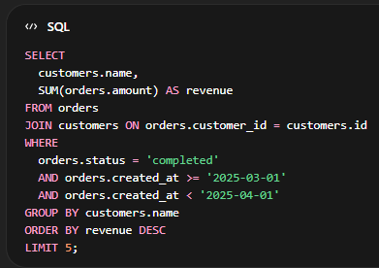

LLM + RAG

What LLM + RAG Means

LLM (Large Language Model): Generates SQL
RAG (Retrieval-Augmented Generation): Feeds only relevant schema/context to the LLM

Step 1: Prepare Your Database Schema

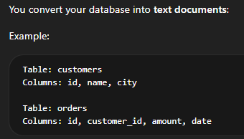

Step 2: Create Embeddings

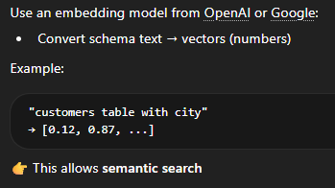

Step 3: Store in Vector Database

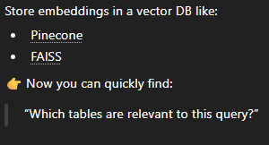

Step 4: User Asks a Question

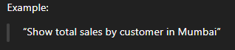

Step 5: Retrieve Relevant Schema (RAG Step)

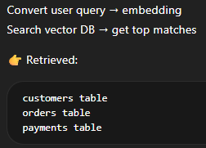

Step 6: Build Prompt for LLM

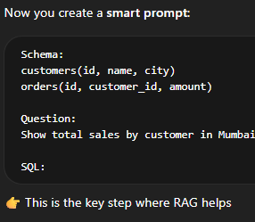

Step 7: LLM Generates SQL

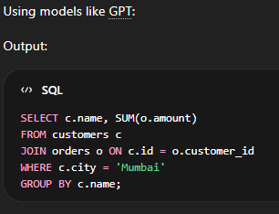

Cost-optimization techniques for Semantic Layer

1.Use LLM Only for Mapping (Not SQL Generation)

Don’t let the LLM write SQL — let it understand intent only.
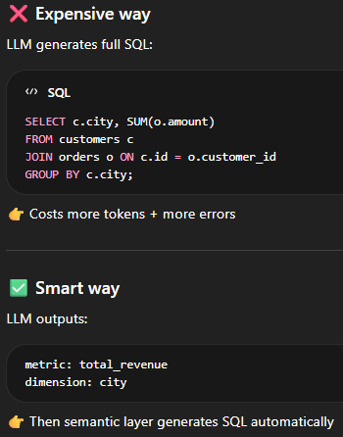

2.Cache Frequent Queries

Don’t repeat work.
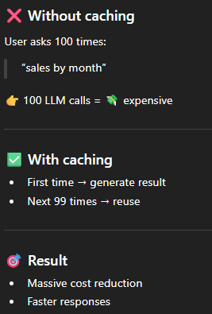

3.Add Lightweight Retrieval (Mini-RAG)

Don’t send everything to the model — only relevant parts.

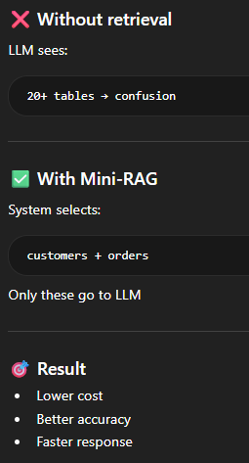

4.Use Cheaper Models for Simple Queries (Model Routing)

Not every question needs a powerful model.
